
UKWA NATIONAL SERIES
SAILING INSTRUCTIONS 2025
Version 1: 15th March 2025
The Organising Authority is the United Kingdom Windsurfing Association (UKWA)

- RULES
  - The Regatta and the series will be governed by the rules as defined in The Racing Rules of Sailing 2025-2028 These include Appendix B (windsurfing fleet racing rules), Appendix WF Wing foiling Racing Rules, the Prescriptions of the RYA, the RYA Racing Charter, the Notice of Race, these Sailing Instructions, and the rules of the relevant International classes as amended by national class rules where applicable.
  - Club, council rules and byelaws apply if displayed on the premises of the club or council hosting the event.

- NOTICES TO COMPETITORS
  - Notices to competitors will be posted on the Virtual Official Notice Board located at https://ukwindsurfing.com/racing/sailing-instructions/ a link is available from the UKWA Website event page.

- CHANGES TO SAILING INSTRUCTIONS
  - Any change to the Sailing Instructions will be posted before 09:00 on the day it will take effect, except that any change to the schedule of races shall be posted before 18:00hrs on the day before it will take effect.
  - Flag L will be displayed to draw the attention of the competitors to any change of the Sailing Instructions or any Notice to Competitors.

- BRIEFING
  - There will be a competitor briefing at 10:15hrs on Saturday and 09:15hrs on Sunday.

- SIGNALS MADE ASHORE
  - Signals made ashore will be displayed on the Official flag pole located on the UKWA events trailer. Signals displayed over a class flag apply to that class only.
  - Boards may not launch to race until their class flag is displayed with one sound signal. The warning signal will be made not less than 20 minutes after the class flag is displayed or not before the scheduled time, whichever is later.
  - When flag AP is displayed ashore competitors shall not go afloat. “1 minute” is replaced with “not less than 10 minutes” in the race signal AP. This changes RRS race signals.
  - For all competitors aged 17 and under on 31st December 2025 RS 40 is amended such that personal flotation devices shall be worn at all times whilst afloat except briefly when changing or adjusting clothing or personal equipment, excluding WindFoils and WingFoils. For all other competitors, when flag Y is displayed RRS 40 applies at all times whilst afloat except briefly when changing or adjusting clothing or personal equipment. This changes part 4 preamble. A personal flotation device may include an impact vest with a minimum of 50 Newtons.
  - When numeral 3 is displayed, every competitor shall wear a wetsuit or drysuit while afloat. A wetsuit is defined as a neoprene garment covering at least the shoulders, torso and legs.

- SCHEDULE OF RACES
  - The normal programme for each fleet will be 4 races per day.
  - The scheduled time of the first start signal is 10:55 on the first day of each event and 09:55 on each subsequent day.
  - On the last scheduled day of the event no warning signal will be made after 16:00.

- CLASS FLAGS/IDENTIFICATION
  - Class flags will be:
Class | Description
5.0, 5.8, 6.8, 7.8, overage and Techno + | Techno 293 insignia on a white background
Raceboard | Raceboard insignia on a blue background
Formula foil, Freeride foil, iQFOiL Senior, iQFOiL youth, & iQFOiL ladies | Formula insignia on a yellow background
iQFOiL Junior | Flag D
Wingfoil | Flag J

  - Identification
    - All competitors shall clearly display the sail number registered on entry on each sail being used, including a change down sail. See NOR 3.7.
  - Wing Foil competitors shall wear a numbered rash vest available from the race office. A £10 cash returnable deposit is charged. It is the wingers responsibility to make sure this number is visible at all times. See NOR 3.7.

- COURSE AREA
The racing area is an area extending 75 metres beyond the course including the starting line, the finishing lines, and their extensions in which a board normally sails whilst racing.

- COURSES
  - Appendix A to these SI’s shows most of the courses likely to be used. If other courses are to be sailed they will be described at a briefing, or posted in a notice to competitors on The Official Notice Board at https://ukwindsurfing.com/racing/sailing-instructions/ Where a gate is shown in the course diagram, it may be replaced by a single mark to be left to port. This will not change the course designation.
  - Please see appendix A and B to these SIs
  - No later than the warning signal, the race committee may fly Numeral 4 to indicate that the course is lengthened by one final windward leg from the mark or gate nearest the starting vessel.

- MARKS
  - Course marks will be large orange inflatable buoys, except that Raceboard WingFoil’s and WindFoil’s mark 1a (windward buoy) will be a large orange inflatable buoy with a yellow shroud with a blue band.
9.1.1 Except that if Courses L & LS are sailed WindFoil’s marks 4s & 4p will be a large orange inflatable buoy with a yellow shroud with a blue band. If not laid marks 4s and 4p will be large orange inflatable buoys.
  - The starting marks will be a race committee boat at the starboard end (including any buoy, object or boat attached to it) and a red inflatable pillar buoy at the port end.
  - The finishing marks will be a race committee boat (including any buoy, object or boat attached to it) and a black inflatable pillar buoy.
  - A board shall not touch a starting or finishing vessel. This changes RRS B3.

- THE START
  - Races will be started using RRS 26 (5, 4, 1, GO). Except that WindFoil & Wingfoil will be started in accordance with appendix C (3, 2, 1, Go). This changes RRS 26
  - The warning signal for any succeeding fleet start will normally be made at least 1 minute after the preceding starting signal.
  - The starting line will be between a staff displaying an orange flag on the race committee signal boat and a red pillar buoy.
  - Boards whose warning signal has not been made shall avoid the starting area.
  - A board starting later than 4 minutes after her starting signal will be scored Did Not Start without a hearing. This changes RRS A4 and A5.
  - An attention signal at the beginning of each series of starts (to alert boards that a race or sequence of races will begin soon) the orange flag will be displayed with one sound signal two minutes before the first warning signal.
  - If a red flag is displayed throughout the start sequence all sailors shall start on Starboard.
  - In RRS 30.1 (I flag) - delete "or one of its extensions".
  - In RRS 30.4 (Black flag) add after “…the race committee shall display her sail number” the words “or otherwise inform her (whenever possible)”.
  - A boat flying an orange flag may be positioned on the extension of the starting line beyond the pin end buoy. Between the preparatory and starting signals no board shall sail between this boat and the pin end buoy.

- CHANGE OF THE NEXT LEG OF THE COURSE
  - To retain the intended alignment of the course to the wind, the race committee may move a mark or the finish line up to 150 metres from its original position without signalling the change. This changes RRS 33.

- THE FINISH
  - The finishing line will be between a staff displaying an orange flag on the race committee signal boat and the finishing mark as shown in Appendix A.
After the first boat has finished, the Race Committee may finish other boards at a mark of the course or on a leg of the course.
When a committee boat displays flag W with two sounds, boards may be finished by this committee boat.
  - When a board finishes in accordance with this instruction, she shall be given a finishing place after all boards which complete more legs of the course and then finish. The finish line will be between the boat flying flag W and a mark of the course. When a board is finished on the course, they should not cross the finish line between the committee boat and finishing mark as shown in Appendix A.
  - If the race committee decides to shorten a course, it will indicate it at a rounding mark by flying code flag S and the flag of class involved, with repeated sound signals, as the leading board approaches that mark. All boards of that class will round that mark and then sail straight across the finish line. This changes RRS 32.
  - Boards who have finished shall at all times keep clear of the finish area.

- TIME LIMITS AND TARGET TIMES
  - Time limit to first mark = 15 minutes.
  - Target time for all classes is 25 minutes, except Raceboards which is 25-30 minutes, except WindFoils and WingFoils which is 15 minutes.

- PENALTY SYSTEM
  - Exoneration Penalty
A board that may have broken a rule of Part 2 (when boats meet) may, after finishing the race concerned and before the start of a related protest hearing, notify the Race Committee that she accepts a 20% scoring penalty as stated in RRS 44.3(c), except that the minimum penalty is five places if that does not result in a score worse than DNF. This penalty does not reverse an OCS score, or a disqualification under RRS 30.3. It is not available for a breach of RRS 2 or of class rules or for gross misconduct under RRS 69. Nor is it available to a board that caused injury or serious damage or gained a significant advantage by her breach: in these circumstances, her penalty is to retire.
When an Exoneration Penalty is accepted:
Neither the board nor a protest committee may then revoke or remove the penalty.
The board shall not be penalized further in a protest hearing when the protest committee decides that it
was appropriate to the facts found and the applicable rules.
When a board accepts an Exoneration Penalty, the designation DPI (Discretionary Penalty Imposed) will be used. If she retires, she will be scored RET.
  - Advisory Hearing
  - When there is an incident that will not result in the lodging of a protest or a request for redress, a board, protest committee or race committee may request an advisory hearing with the race office, and notify any board involved in the incident. An adviser will then call a hearing to learn what may have happened and will state whether any rule appears to have been broken, and by which board. A board may as a result notify the race office that she accepts an Exoneration Penalty when it applies to the incident, or choose to retire, although there is no requirement for her to do either. Redress is not available.
  - RYA Arbitration
a) When a protest or request for redress is lodged, a board may at the same time request RYA Arbitration, or the protest committee or race committee may offer it.
b) If the parties and a member of the protest or race committee agree that RYA Arbitration is suitable, an arbitrator (who may be that member of the protest committee) will call a hearing. When the arbitrator decides that a board that is a party to the arbitration hearing has broken a rule for which the Exoneration Penalty is available, the party will be invited to accept that penalty, and, if it is accepted by a protested board, the protesting board will be allowed to withdraw the protest, changing RRS 63.1.
c) When there is not an agreement to use RYA Arbitration, or when, after RYA Arbitration, a protest is not withdrawn or the Exoneration Penalty is not applicable to the facts, there will be a normal protest hearing, at which the arbitrator may be a member of the protest committee. RRS 66 and 70 will not apply to the arbitration decision. A board may still accept an Exoneration Penalty at any time before the start of a protest hearing and receive its protection from further penalization. She may also retire.
d) When a protest or request for redress is lodged, a board may at the same time request RYA Arbitration, or the protest committee or race committee may offer it.
Breaches of sailing instructions 5,4, 5.5, 7.2, 10.4, 10.9, 17 and 18 will not be grounds for a protest by a board. This changes RRS 60.1(a). Penalties for these breaches may be less than disqualification if the protest committee so decides.
  - On the last scheduled day of racing a request for reopening a hearing shall be delivered:
By 12:00 if the requesting party was informed of the decision on the previous day;
No later than 10 minutes after the requesting party was informed of the decision.

- PROTESTS AND REQUESTS FOR REDRESS
  - Boards intending to protest must inform the race committee of her intention to protest as soon as practicable after she finishes or retires.
  - Protest forms are available at the Race Office. Protests and requests for redress or reopening shall be delivered there within the time limit.
  - For each fleet, the protest time limit is 30 minutes after the last board in that fleet has finished the last race of the day or from the time that the Race Committee signals no more racing for that day.
  - Notices will be posted no later than 30 minutes after the protest time limit to inform competitors of hearings in which they are parties or named as witnesses. A further notice will be posted with details of the location of the protest room and the time for the first hearing.
  - When a board takes a penalty or retires under RRS 44.1, the penalty is changed to include completion of an acknowledgement form at the race office within the protest time limit.

- EVENT SCORING
  - 1 race is required to be completed to constitute a regatta for all boards of that class.
  - 3 races must be completed for the event to count towards the series.
  - The Low Point Scoring System of Appendix A will apply, including RRS A8
  - When fewer than 3 races have been completed, a board’s series score will be the total of her race scores. When 3 to 6 races have been completed, a board’s series score will be the total of her race scores excluding her worst score.
When 7 to 10 races have been completed, a board’s series score will be the total of her race scores excluding her two worst scores.
When 11 or more races have been completed, a board's series score will be the total of her race scores excluding her three worst scores.
  - To request correction of an alleged error in posted results or series results, a boat shall complete a scoring enquiry form at the Race Office.

- TALLY SYSTEM
  - A tally system will be used to record each competitor going afloat, and to record their safe return. Tallies are numbered coloured wristbands and shall be taken just before going afloat, when authorised by the beach master, and shall be returned immediately on returning to shore. Any competitor who does not comply with the system will be issued a 20% scoring penalty for that race. In the case of back to back races the penalty will apply to the first race only.
  - Competitors who are already afloat and who realise they have forgotten their tally must inform an official boat at the first opportunity and the race office upon returning to shore.
  - The tally system, to check-out and check-in competitors, will be located at the UKWA Events Trailer.
  - Tallies shall be worn visibly, over clothing.
  - Tally number and colour will be allocated after registration, with tally numbers for individual sailors posted on the official notice board at ukwindsurfing.com/racing/sailing-instructions/

- SAFETY
  - Mandatory Instructions on the Water - Boards and Competitors in Difficulty. When the race committee considers that a board, its equipment, or crew are not adequate for the existing or anticipated conditions, or that a board or crew member is in difficulty, it may instruct the board or crew not to launch, or to retire or to sail ashore or to accept outside help. The board and crew shall comply with such instructions without delay.
  - Boards shall not jump within the racing area. A competitor failing to comply will be scored a DSQ without a hearing. For an incident in a race the penalty shall be applied for that race. For an incident outside of a race the penalty shall be applied to the preceding race.

- EQUIPMENT AND MEASUREMENT CHECKS
  - A board or equipment may be inspected at any time for compliance with the class rules and sailing instructions. On the water, a board can be instructed by the technical committee equipment inspector to proceed immediately to a designated area for inspection.
  - A sailor wishing to race in the Techno 5.0, 5.8 Class must ensure that their sail has a maximum of 6 battens and 2 cams.

- SUPPORT & COACH BOATS / PERSONS
  - Team leaders, coaches and other support personnel who have had approval to attend by the Head of Racing shall stay outside areas where boards are racing from the time of the preparatory signal for the first class to start until all boards have finished or retired or the race committee signals a postponement, general recall or abandonment.
  - Coach and support boats with approval of the Head of Racing, must keep out of the racing area at all times, unless given permission to enter by a race official.
  - Coach and support boats shall comply with any reasonable request from a race official
  - If the protest committee learns of a possible breach of a rule by a support person through any source, including the Race Committee, it may call a hearing under rule 62

- LITTER DISPOSAL
  - Boards shall not put litter in the water (RRS 47).

- RADIO COMMUNICATION
  - A board shall neither make nor receive radio or mobile telephone transmissions while racing.

- PRIZES
  - A list of prizes to be awarded may be posted on the Official Notice Board after registration is completed.

- DISCLAIMER OF LIABILITY
  - Risk Statement
RRS 4 of the Racing Rules of Sailing states: “The responsibility for a boat’s decision to participate in a race or to continue racing is hers alone.”
Sailing is by its nature an unpredictable sport and therefore inherently involves an element of risk. By taking part in the event, each competitor agrees and acknowledges that:
a) They are aware of the inherent element of risk involved in the sport and accept responsibility for the exposure of themselves, their crew and their boat to such inherent risk whilst taking part in the event;
b) They are responsible for the safety of themselves, their crew, their boat and their other property whether afloat or ashore;
c) They accept responsibility for any injury, damage or loss to the extent caused by their own actions or omission;
d) Their boat is in good order, equipped to sail in the event and they are fit to participate;
e) The provision of a race management team, patrol boats and other officials and volunteers by the event organiser does not relieve them of their own responsibilities;
f) The provision of patrol boat cover is limited to such assistance, particularly in extreme weather conditions, as can be practically provided in the circumstances.
g) It is their responsibility to familiarise themselves with any risk specific to this venue or this event drawn to their attention in any rules and information produced for the venue or event and to attend any safety briefing held for the event, in person or virtually.

- INSURANCE
  - Each participating board shall be insured with valid third-party liability insurance with a minimum cover of £5,000,000 per event or the equivalent.

Appendix A:

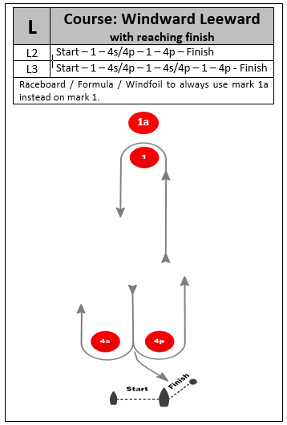
Marks 3s & 4s may not be laid. In which case the single mark is to be left to port.

Raceboard / WindFoil / WingFoil to always use mark 1a instead of mark 1.

L1 | Start – 1 – 4p – Finish

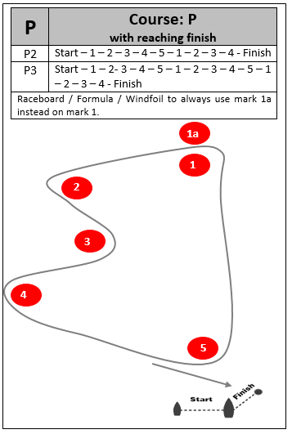

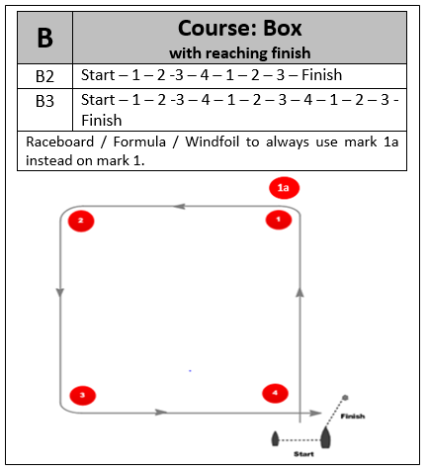

Raceboard / WindFoil / WingFoil to always use mark 1a instead of mark 1.

Raceboard / WindFoil / WingFoil to always use mark 1a instead of mark 1.

B1 | Start – 1 – 2 - 3 – Finish

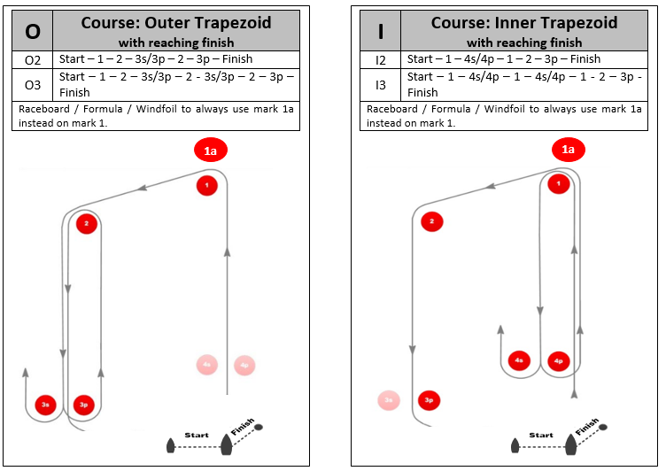

Raceboard / Windfoil / WingFoil to always use mark 1a instead of mark 1.

Raceboard / Windfoil / WingFoil to always use mark 1a instead of mark 1.

Appendix B:
1.1 When flag C and a class flag are displayed on the race committee boat prior to a start, sailors shall prepare to sail course C, D or U as indicated on the Slalom Start Boat
1.2 When flag C and a class flag are displayed on the finish boat, sailors shall prepare to change course.
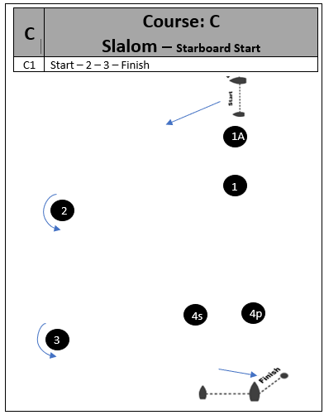
D | Course: D  Sprint Slalom – Downwind slalom course Port
 | Start – 1 – 2 – 3 – Finish

D | Course: D  Sprint Slalom – Downwind slalom course Starboard
 | Start – 1 – 2 – 3 – Finish

U | Course: U  Sprint Slalom – U Slalom Course Port
 | Start – 1 – 2 – 3 – 4 -Finish

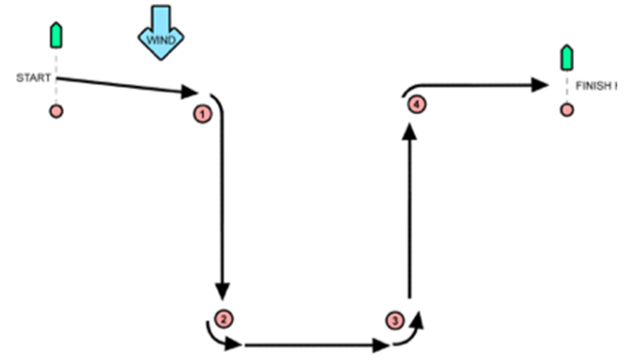

U | Course: U  Sprint Slalom – U Slalom Course Starboard
 | Start – 1 – 2 – 3 – 4 -Finish

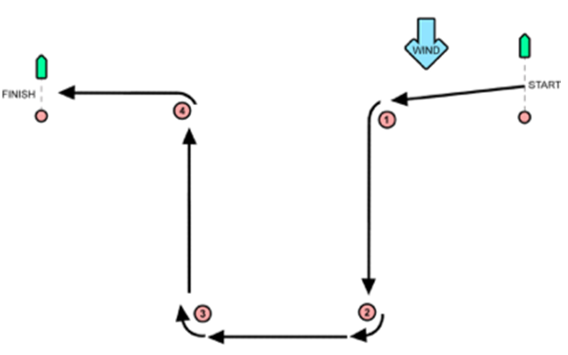

Appendix C:
Signal | Flag & Sound | Minutes before Start
Warning | Class Flag Displayed; 1 Sound | 3
Preparatory | Preparatory Displayed; 1 Sound | 2
 | Preparatory Removed; 1 Sound | 1
Starting | Class Flag Removed; 1 Sound | 0

